DBMS LAB ASSIGNMENT-1

**Name: M.joshasree**

**Roll No:** 19BCS069

**Group No:** 5

ER DIAGRAM:

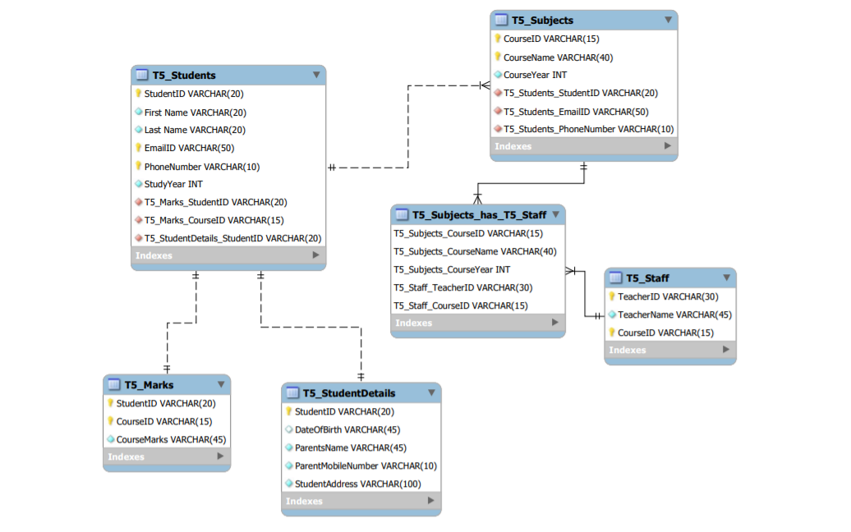

The entity which do not have any primary key, cannot be identified on their own and depend on some other entity is known as weak entity.

Here, the entity **T5_Subjects_has_T5_Staff** is weak entity.

A weak, or non-identifying relationship exists if the primary key of the related entity does not contain a primary key component of the parent entity.

Here, weak relations are between:

1. T5_Students, T5_Subjects_has_T5_Staff
2. T5_Staff, T5_Subjects_has_T5_Staff